PackNGo

UseCase Description:
PackNGo aims to improve its travel services by creating a simple and efficient Travel Booking System using the Pega Platform. This application will streamline key operations, including customer registration, travel planning, and food service management. Customers will be able to create accounts, select travel dates, budgets, locations, and modes of transport, as well as query and book meals directly through the portal. Travel managers will have the ability to review and manage customer bookings, including the approval or rejection of travel cancellations, while food managers can similarly handle food booking cancellations. Additionally, the system will provide travel managers with a unified view of all customer bookings, enabling efficient oversight and better service delivery. By automating these processes, PackNGo aims to reduce operational inefficiencies, improve user experiences, and support scalable growth in its travel solutions.

Requirements:
Using this online web application
- All the customers will be able to…
- Register or login to the customer portal.
- Allowing customers to choose the dates, budget and location along with mode of travel.
- Select their food options for breakfast/lunch/dinner.
- Customer should pay 50% of the total amount for confirming the booking.
- Customer can cancel the travel booking or food plan.
- Travel Manager and Food Manager will be able to…
- Access the reservation request submitted by the customers.
- Approve/reject the new/cancellation request on reservations.

Application Structure:
- Organisation : MARS
- Application Name : PackNGo
- Division : Div
- Unit : Unit
Case types:
- Travel Booking

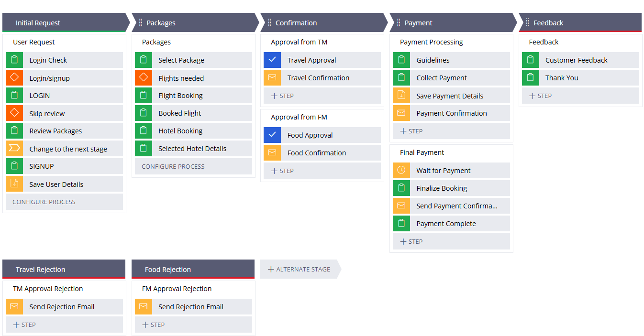

- Cancellation

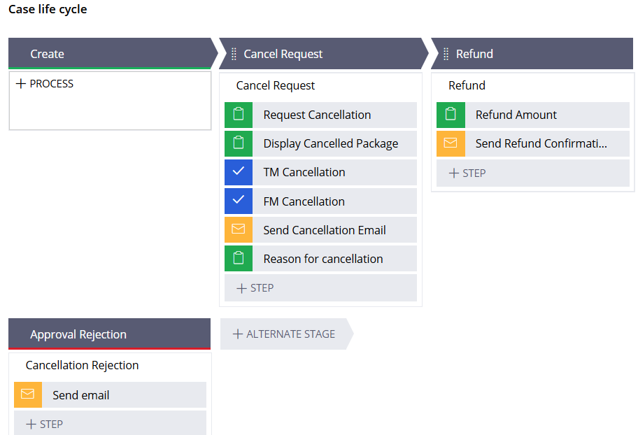

Mock-up Screens:
Case Type 1: Holiday Booking
Screen-1:
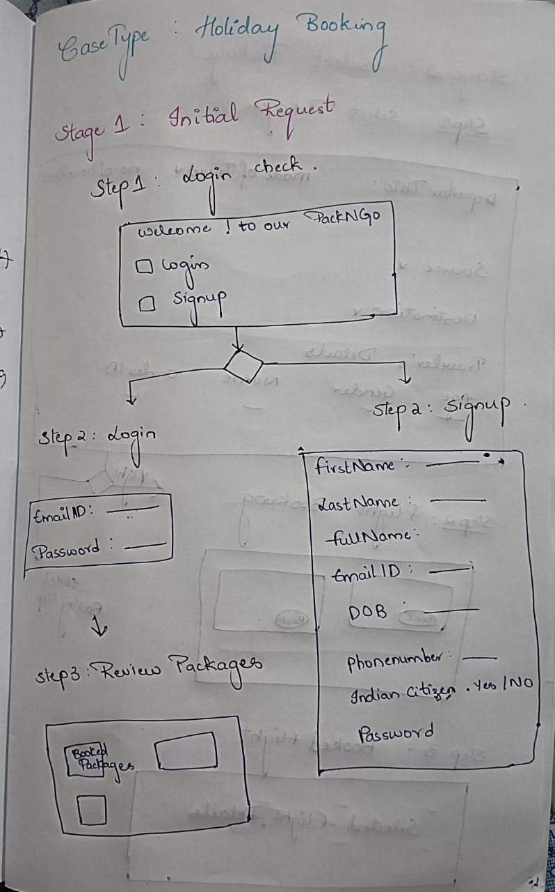

Screen-2:
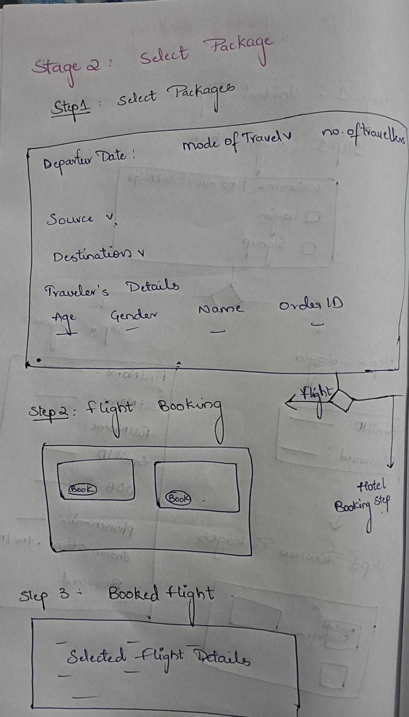

Screen-3:
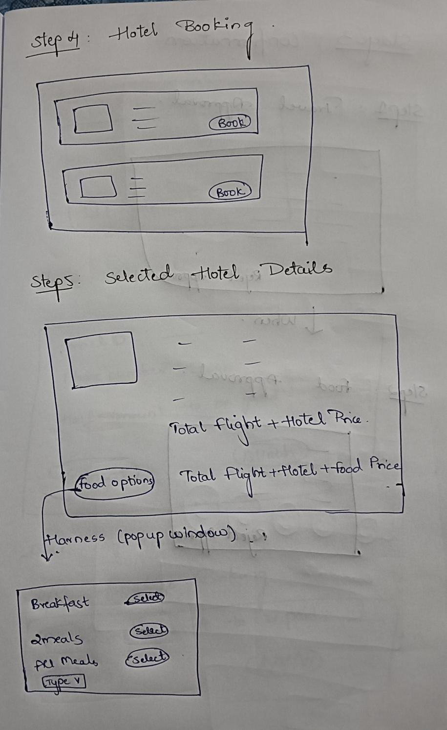
Screen-4:
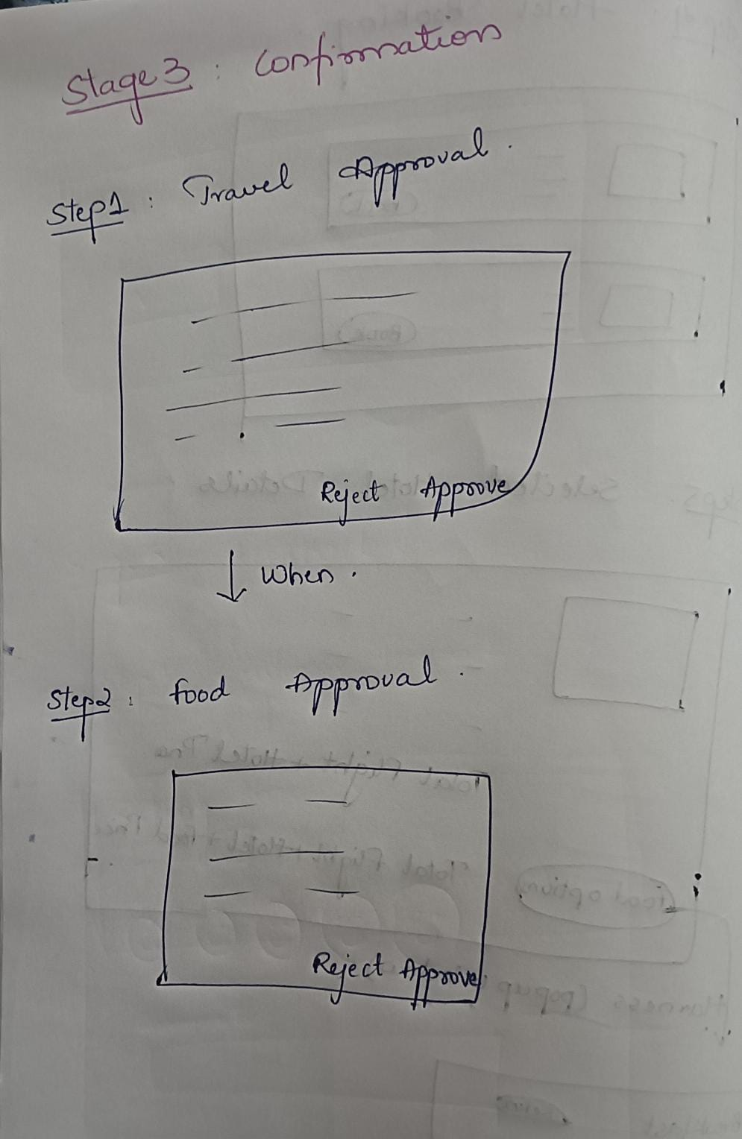
Screen-5:
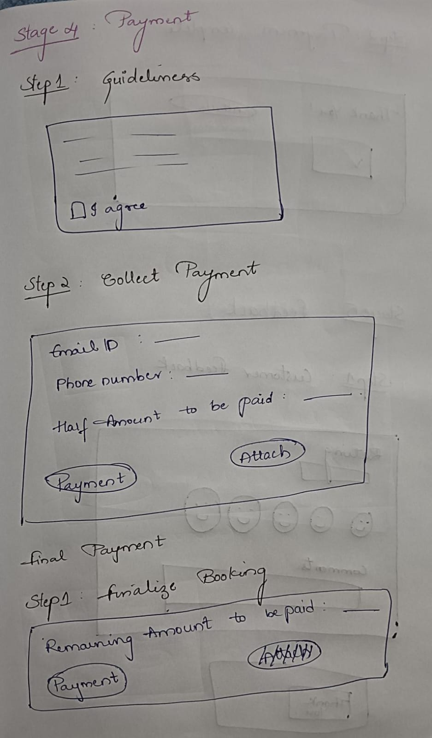
Screen 6:
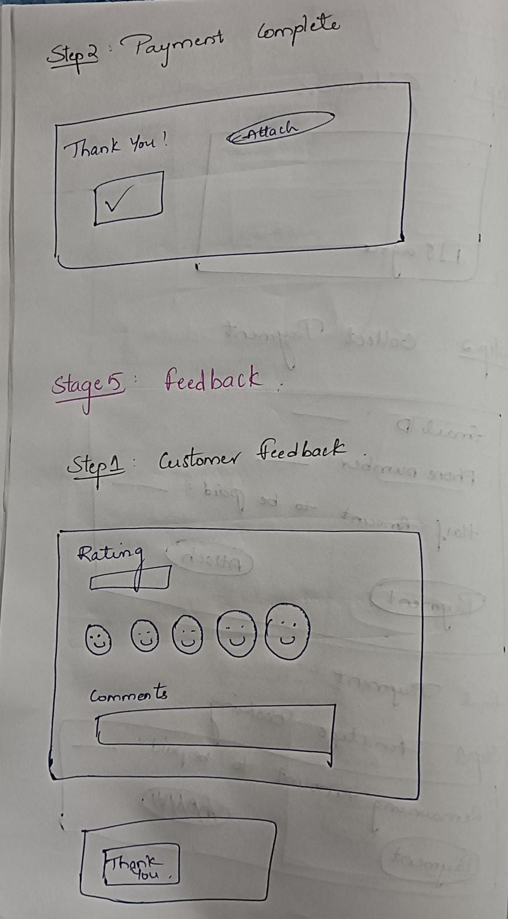

Case Type 2: Cancellation
Screen 1:
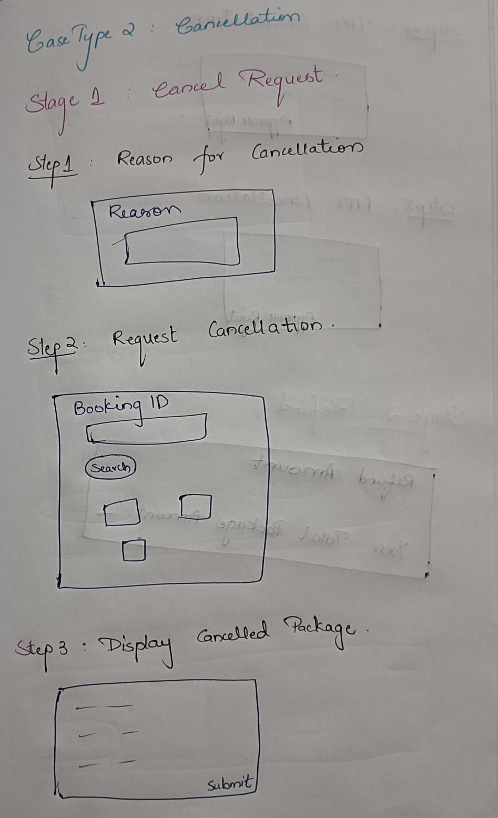

Screen 2:
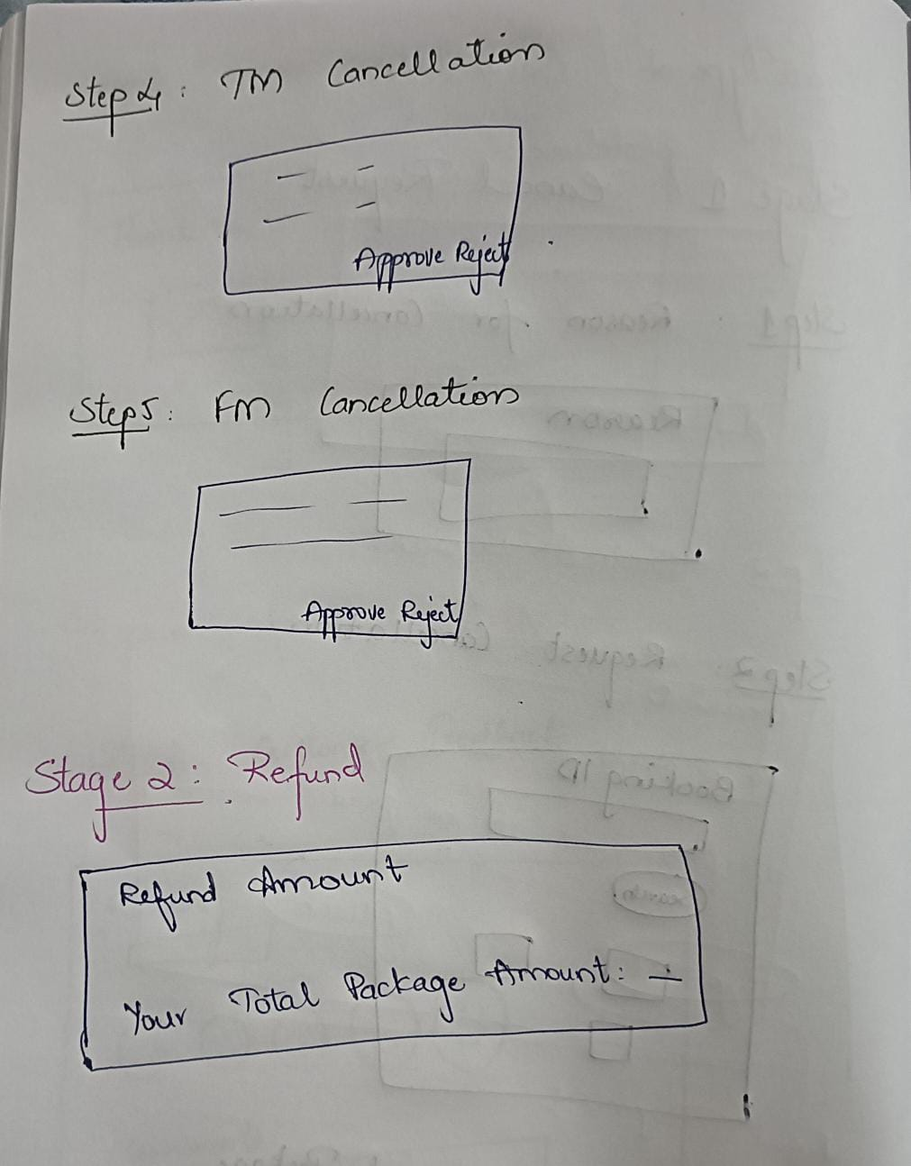

Data Model:
- User
- First Name
- Last Name
- Email ID (User Id)
- Password
- DOB
- Contact Number
- Address(City , State , Pincode)
- Travel
- From Date
- To date
- Location
- No of Travellers
- Budget
- Food Details
- Breakfast
- Lunch
- Dinner
- Packages
- Travel Package Name
- Location
- Total Price
- Payment
- Card Number
- Card Holder Name
- CVV
- Date of Expiry
- Optional (Online Payment)

Data Model Design:
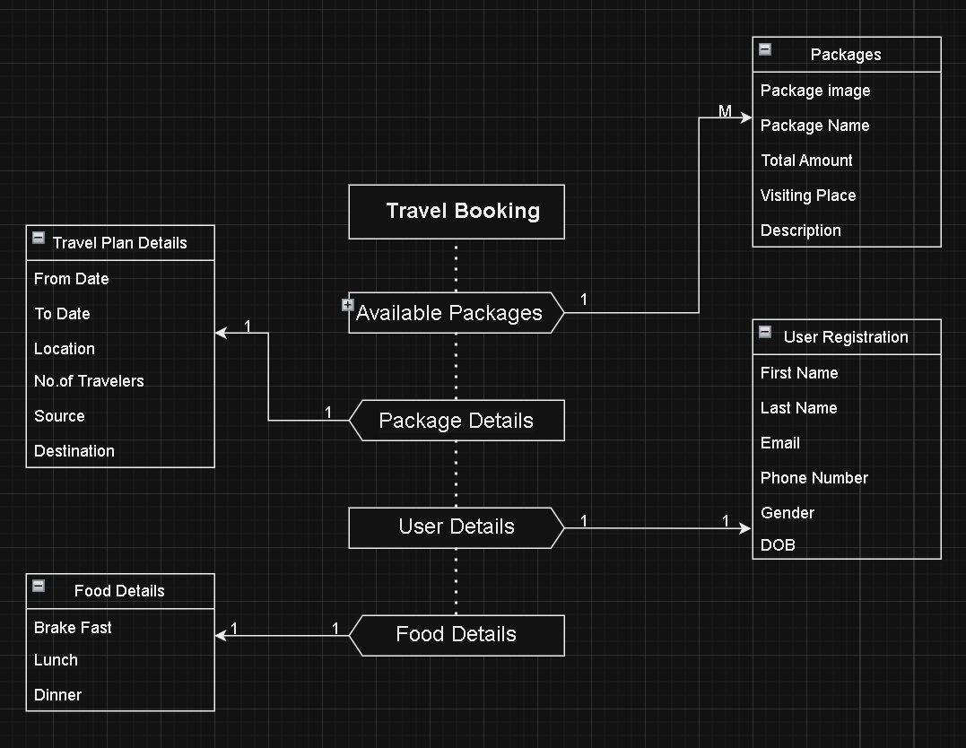

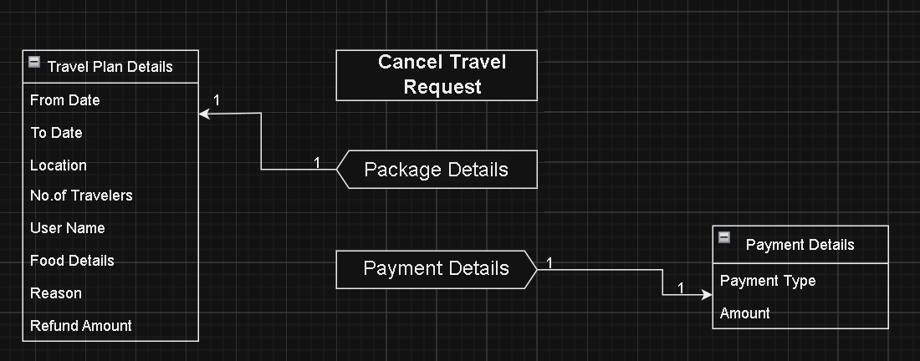

Enterprise Class Structure:

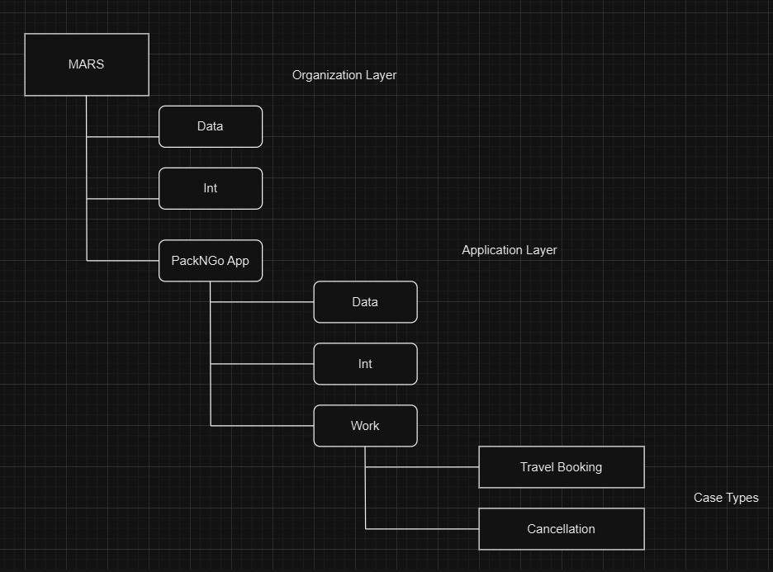

Portals:
- Customer Portal
- Travel Manager Portal
- Food Manager Portal
- Admin Portal
Routing:

- Customer travel booking request should be routed to travel manager.

- If the customer selects a food plan then it should be routed to the food manager.

- If a customer wants to cancel the request then it will be routed to the travel/food manager to approve/reject the cancellation.

Validations done on:

- Email ID and Password
- Password
- DOB
- Phone number
- Departure date

Actors:
- Customer
- Application Admin
- Travel Manager
- Food Manager

Access Groups:
- Application Admin (admin@mars)
- Travel Manager (PackNGo:TravelManager)
- Food Manager (PackNGo:FoodManager)
- Customer (PackNGo:Customer)

Access Roles:
- Application Admin
- Travel Manager
- Food Manager
- Customer

